Chapter 1

Introduction

to

networking

**Data Communication**: When we communicate, we are sharing information. This sharing can be local or remote. Between individuals, local communication usually occurs face to face, while remote communication takes place over distance.

Components: A data communications system has five components.

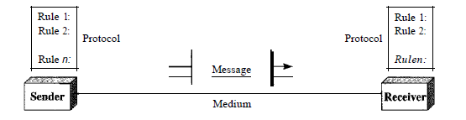

1. Message. The message is the information (data) to be communicated. Popular forms of information include text, numbers, pictures, audio, and video.

2. Sender. The sender is the device that sends the data message. It can be a computer, workstation, telephone handset, video camera, and so on.

3. Receiver. The receiver is the device that receives the message. It can be a computer, workstation, telephone handset, television, and so on.

4. Transmission medium. The transmission medium is the physical path by which a message travels from sender to receiver. Some examples of transmission media include twisted-pair wire, coaxial cable, fiber-optic cable, and radio waves .

5. Protocol. A protocol is a set of rules that govern data communications. It represents an agreement between the communicating devices.

**Computer Network**

* A **computer network** is a set of **computers** connected together for the purpose of sharing resources.
* The connection between computers can be done via cabling, most commonly the Ethernet cable, or wirelessly through radio waves.
* Connected computers share recourses like access the internet, printer, file server.

**Types of networking devices**

**Repeater**

A repeater operates at the physical layer. Its job is to regenerate the signal over the same network before the signal becomes too weak or corrupted so as to extend the length to which the signal can be transmitted over the same network. An important point to be noted about repeaters is that they do not amplify the signal. When the signal becomes weak, they copy the signal bit by bit and regenerate it at the original strength. It is a 2 port device.

## Hub

A Hub is a hardware device that divides the network connection among multiple devices. When computer requests for some information from a network, it first sends the request to the Hub through cable. Hub will broadcast this request to the entire network. All the devices will check whether the request belongs to them or not. If not, the request will be dropped.

The process used by the Hub consumes more bandwidth and limits the amount of communication. Nowadays, the use of hub is obsolete, and it is replaced by more advanced computer network components such as Switches, Routers.

**Types of Hub**

* **Active Hub:-**These are the hubs that have their own power supply and can clean, boost, and relay the signal along with the network. It serves both as a repeater as well as a wiring center. These are used to extend the maximum distance between nodes.
* **Passive Hub :-**These are the hubs that collect wiring from nodes and power supply from the active hub. These hubs relay signals onto the network without cleaning and boosting them and can’t be used to extend the distance between nodes.

**Bridge**

A bridge operates at the data link layer. A bridge is a repeater, with add on the functionality of filtering content by reading the MAC addresses of source and destination. It is also used for interconnecting two LANs working on the same protocol. It has a single input and single output port, thus making it a 2 port device.

## Switch

**Switch** is a network device that connects other devices to **Ethernet** networks through **twisted pair** cables. It uses **packet switching** technique to **receive, store** and **forward data packets** on the network. The switch maintains a list of network addresses of all the devices connected to it.

On receiving a packet, it checks the destination address and transmits the packet to the correct port. Before forwarding, the packets are checked for collision and other network errors. The data is transmitted in full duplex mode

    
[**Routers**](https://www.geeksforgeeks.org/network-devices-hub-repeater-bridge-switch-router-gateways/#Routers) – A router is a device like a switch that routes data packets based on their IP addresses. The router is mainly a Network Layer device. Routers normally connect LANs and WANs together and have a dynamically updating routing table based on which they make decisions on routing the data packets. Router divide broadcast domains of hosts connected through it.

**Gateway** – A gateway, as the name suggests, is a passage to connect two networks together that may work upon different networking models. They basically work as the messenger agents that take data from one system, interpret it, and transfer it to another system. Gateways are also called protocol converters and can operate at any network layer. Gateways are generally more complex than switches or routers. Gateway is also called a protocol converter.

**Topology**

The arrangement of a network that comprises nodes and connecting lines via sender and receiver is referred to as network topology. The various network topologies are : 

**a) Mesh Topology:**

In a mesh topology, every device is connected to another device via the particular channel.

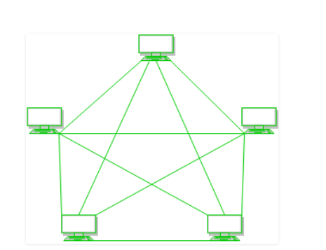

**Figure 1**: Every device is connected with another via dedicated channels. These channels are known as links. 

* If suppose, N number of devices are connected with each other in a mesh topology, the total number of ports that are required by each device is N-1. In Figure 1, there are 5 devices connected to each other, hence the total number of ports required by each device is 4. Total number of ports required=N*(N-1).
* If suppose, N number of devices are connected with each other in a mesh topology, then a total number of dedicated links required to connect them is NC2 i.e. N(N-1)/2. In Figure 1, there are 5 devices connected to each other, hence the total number of links required is 5*4/2 = 10.

**Advantages of this topology:**

* It is robust.
* The fault is diagnosed easily. Data is reliable because data is transferred among the devices through dedicated channels or links.
* Provides security and privacy.

**Problems with this topology:**

* Installation and configuration are difficult.
* The cost of cables is high as bulk wiring is required, hence suitable for less number of devices.
* The cost of maintenance is high.

**b) Star Topology:**

In star topology, all the devices are connected to a single hub through a cable. This hub is the central node and all other nodes are connected to the central node. The hub can be passive in nature i.e., not intelligent hub such as broadcasting devices, at the same time the hub can be intelligent known as active hubs. Active hubs have repeaters in them.

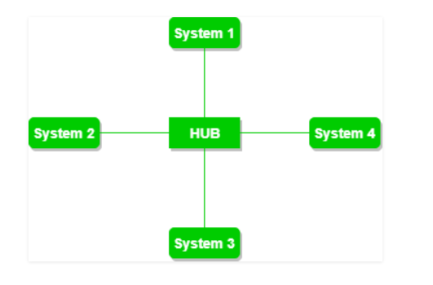

**Figure 2**: A star topology having four systems connected to single point of connection i.e. hub.

a **Advantages of this topology:**

* If N devices are connected to each other in a star topology, then the number of cables required to connect them is N. So, it is easy to set up.
* Each device requires only 1 port i.e. to connect to the hub, therefore total number of ports required is N.

**Problems with this topology:**

* If the concentrator (hub) on which the whole topology relies fails, the whole system will crash down.
* The cost of installation is high.
* Performance is based on the single concentrator i.e. hub.

**c) Bus Topology:**

Bus topology is a network type in which every computer and network device is connected to a single cable. It transmits the data from one end to another in a single direction. No bi-directional feature is in bus topology. It is a multi-point connection and a non-robust topology because if the backbone fails the topology crashes.

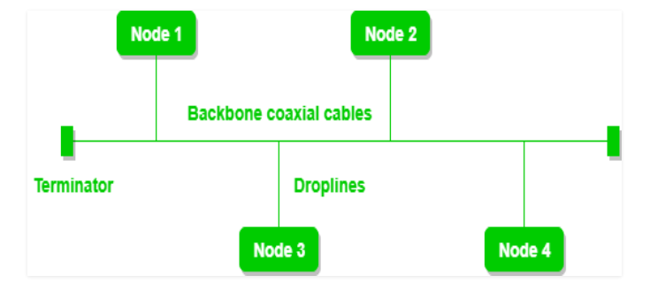

**Figure 3**: A bus topology with shared backbone cable. The nodes are connected to the channel via drop lines.

**Advantages of this topology:**

* If N devices are connected to each other in a bus topology, then the number of cables required to connect them is 1, which is known as backbone cable, and N drop lines are required.
* The cost of the cable is less as compared to other topologies, but it is used to build small networks.

**Problems with this topology:**

* If the common cable fails, then the whole system will crash down.
* If the network traffic is heavy, it increases collisions in the network. To avoid this, various protocols are used in the MAC layer known as Pure Aloha, Slotted Aloha, CSMA/CD, etc.
* Security is very low.

**d) Ring Topology:**

In this topology, it forms a ring connecting devices with its exactly two neighboring devices.

A number of repeaters are used for Ring topology with a large number of nodes, because if someone wants to send some data to the last node in the ring topology with 100 nodes, then the data will have to pass through 99 nodes to reach the 100th node. Hence to prevent data loss repeaters are used in the network.

The transmission is unidirectional, but it can be made bidirectional by having 2 connections between each Network Node, it is called Dual Ring Topology.

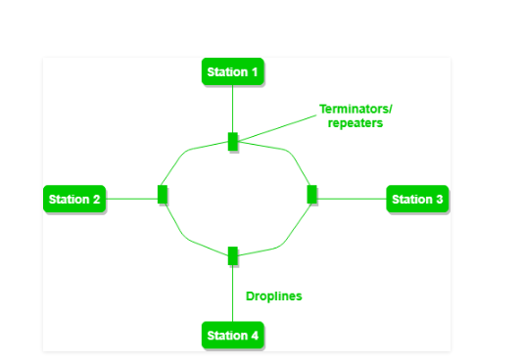

**Figure 4:** A ring topology comprises of 4 stations connected with each forming a ring.

The following operations take place in ring topology are : 

1. One station is known as **monitor** station which takes all the responsibility to perform the operations.
2. To transmit the data, the station has to hold the token. After the transmission is done, the token is to be released for other stations to use.
3. When no station is transmitting the data, then the token will circulate in the ring.
4. There are two types of token release techniques: **Early token release** releases the token just after transmitting the data and **Delay token release** releases the token after the acknowledgment is received from the receiver.

**Advantages of this topology:**

* The possibility of collision is minimum in this type of topology.
* Cheap to install and expand.

**Problems with this topology:**

* Troubleshooting is difficult in this topology.
* The addition of stations in between or removal of stations can disturb the whole topology.
* Less secure.

**e) Tree Topology:**

This topology is the variation of Star topology. This topology has a hierarchical flow of data.

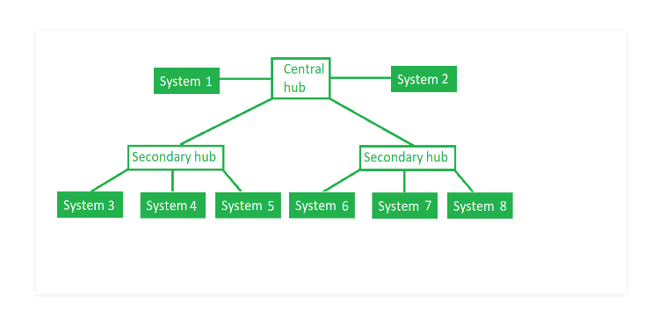

**Figure 5**: In this, the various secondary hubs are connected to the central hub which contains the repeater. In this data flow from top to bottom i.e. from the central hub to secondary and then to the devices or from bottom to top i.e. devices to the secondary hub and then to the central hub. It is a multi-point connection and a non-robust topology because if the backbone fails the topology crashes.  
**Advantages of this topology :** 

* It allows more devices to be attached to a single central hub thus it increases the distance that is travel by the signal to come to the devices.
* It allows the network to get isolate and also prioritize from different computers.

**Problems with this topology :** 

* If the central hub gets fails the entire system fails.
* The cost is high because of cabling.

**Design issues for layers**

The following are the design issues for the layers:

* **Reliability:** It is a design issue of making a network that operates correctly even when it is made up of unreliable components.
* **Addressing:** There are multiple processes running on one machine. Every layer needs a mechanism to identify senders and receivers.
* **Error Control**: It is an important issue because physical communication circuits are not perfect. Many error detecting and error correcting codes are available. Both sending and receiving ends must agree to use any one code.
* **Flow Control:** If there is a fast sender at one end sending data to a slow receiver, then there must be flow control mechanism to control the loss of data by slow receivers. There are several mechanisms used for flow control such as increasing buffer size at receivers, slow down the fast sender, and so on. Some process will not be in position to accept arbitrarily long messages. This property leads to mechanisms for disassembling, transmitting and the reassembling messages.
* **Multiplexing and De-multiplexing:** If the data has to be transmitted on transmission media separately, it is inconvenient or expensive to setup separate connection for each pair of communicating processes. So, multiplexing is needed in the physical layer at sender end and de-multiplexing is need at the receiver end.
* **Scalability**: When network gets large, new problem arises. Thus scalability is important so that network can continue to work well when it gets large.
* **Routing:** When there are multiple paths between source and destination, only one route must be chosen. This decision is made on the basis of several routing algorithms, which chooses optimized route to the destination.
* **Confidentiality and Integrity:** Network security is the most important factor. Mechanisms that provide confidentiality defend against threats like eavesdropping. Mechanisms for integrity prevent faulty changes to messages.

**Connectionless and Connection oriented services**

|  |  |  |
| --- | --- | --- |
| **Sr. No** | **Connection oriented** | **Connectionless** |
| 1 | virtual connection is created before sending the packet over the internet | In this communication service, packets are sent without creating any virtual connection over the internet. |
| 2 | It needs authentication of the destination node before transferring data. | It transfers the data message without authenticating destination |
| 3 | This is a more reliable connection | This connection does not ensure reliability on packet transmission |
| 4 | The handshaking is carried out to ensure both sender and receiver agrees with this connection. | There is no handshaking happens while sending a packet over the network. |
| 5 | It is slower than the connectionless service. | It is faster than connection-oriented protocol service. |
| 6 | Sending packet in connection-oriented service requires more parameters in the header. | It has less overhead and smaller packet header size. |
| 7 | Route is finalized and decided at the time of handshaking before sending the actual packet. | The route is not finalized |
| 8 | All the packets between sender and destination follow the same path. | Not necessary all the packets transmitting between sender and receiver follows the same path. |
| 9 | TCP is connection-oriented protocol. | UDP is connectionless protocol. |

**Layers of OSI Model**

* OSI stands for **Open Systems Interconnection**. It has been developed by ISO – ‘**International Organization of Standardization**‘, in the year 1984.
* It is a 7-layer architecture with each layer having specific functionality to perform.
* All these 7 layers work collaboratively to transmit the data from one person to another across the globe.

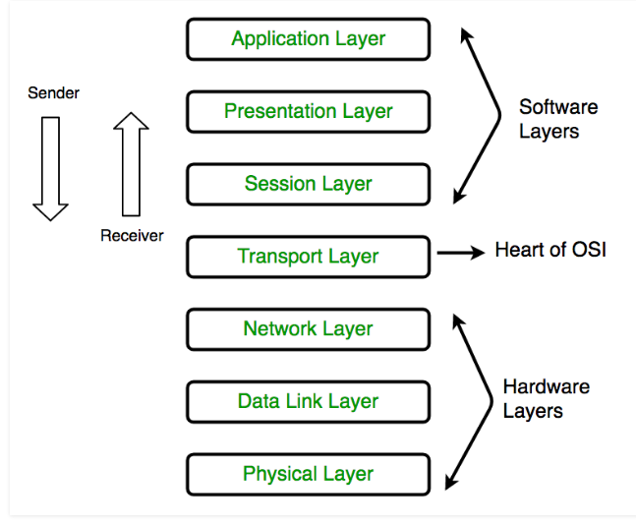

**Physical Layer**

* The lowest layer of the OSI reference model is the physical layer. It is responsible for the actual physical connection between the devices.
* The physical layer contains information in the form of**bits.** It is responsible for transmitting individual bits from one node to the next.
* When receiving data, this layer will get the signal received and convert it into 0s and 1s and send them to the Data Link layer, which will put the frame back together.

The functions of the physical layer are:

* **Bit synchronization:** The physical layer provides the synchronization of the bits by providing a clock. This clock controls both sender and receiver thus providing synchronization at bit level.
* **Bit rate control:** The Physical layer also defines the transmission rate i.e. the number of bits sent per second.
* **Physical topologies:** Physical layer specifies the way in which the different, devices/nodes are arranged in a network i.e. bus, star or mesh topology.
* **Transmission mode:** Physical layer also defines the way in which the data flows between the two connected devices. The various transmission modes possible are: Simplex, half-duplex and full-duplex.

**Data link Layer**

* The data link layer is responsible for the node to node delivery of the message.
* The main function of this layer is to make sure data transfer is error-free from one node to another, over the physical layer. When a packet arrives in a network, it is the responsibility of DLL to transmit it to the Host using its MAC address.  
  Data Link Layer is divided into two sub layers :
* Logical Link Control (LLC)
* Media Access Control (MAC)

The functions of the data Link layer are:

* **Framing:**Framing is a function of the data link layer. It provides a way for a sender to transmit a set of bits that are meaningful to the receiver. This can be accomplished by attaching special bit patterns to the beginning and end of the frame.

**0101 0101 0010 1011 01010101010**

* **Physical addressing:** After creating frames, Data link layer adds physical addresses (MAC address) of sender and/or receiver in the header of each frame.
* **Error control:** Data link layer provides the mechanism of error control in which it detects and retransmits damaged or lost frames.
* **Flow Control:** The data rate must be constant on both sides else the data may get corrupted thus, flow control coordinates that amount of data that can be sent before receiving acknowledgement.
* **Access control:**When a single communication channel is shared by multiple devices, MAC sub-layer of data link layer helps to determine which device has control over the channel at a given time.

**Network Layer**

* Network layer works for the transmission of data from one host to the other located in different networks.
* It also takes care of packet routing i.e. selection of the shortest path to transmit the packet, from the number of routes available.
* The sender & receiver’s IP address are placed in the header by the network layer.

The functions of the Network layer are:

* **Routing:** The network layer protocols determine which route is suitable from source to destination. This function of network layer is known as routing.
* **Logical Addressing:**In order to identify each device on internetwork uniquely, network layer defines an addressing scheme. The sender & receiver’s IP address are placed in the header by network layer. Such an address distinguishes each device uniquely and universally.

**Transport Layer**

* Transport layer provides services to application layer and takes services from network layer.
* The data in the transport layer is referred to as *Segments*.
* It is responsible for the End to End Delivery of the complete message.
* The transport layer also provides the acknowledgement of the successful data transmission and re-transmits the data if an error is found.

The services provided by the transport layer:

**Connection Oriented Service:** It is a three-phase process which include  
– Connection Establishment  
– Data Transfer  
– Termination / disconnection  
In this type of transmission, the receiving device sends an acknowledgement, back to the source after a packet or group of packet is received. This type of transmission is reliable and secure.

**Connection less service:** It is a one-phase process and includes Data Transfer. In this type of transmission, the receiver does not acknowledge receipt of a packet. This approach allows for much faster communication between devices. Connection-oriented service is more reliable than connectionless Service

**Session Layer**

* This layer is responsible for establishment of connection, maintenance of sessions, authentication and also ensures security.  
  The functions of the session layer are :
* **Session establishment, maintenance and termination:** The layer allows the two processes to establish, use and terminate a connection.
* **Synchronization:** This layer allows a process to add checkpoints which are considered as synchronization points into the data. These synchronization point help to identify the error so that the data is re-synchronized properly, and ends of the messages are not cut prematurely and data loss is avoided.
* **Dialog Controller:** The session layer allows two systems to start communication with each other in half-duplex or full-duplex.

**Presentation Layer**

* Presentation layer is also called the **Translation layer**. The data from the application layer is extracted here and manipulated as per the required format to transmit over the network.  
  The functions of the presentation layer are :
* **Translation:** For example, ASCII to EBCDIC.
* **Encryption/ Decryption:** Data encryption translates the data into another form or code. The encrypted data is known as the cipher text and the decrypted data is known as plain text. A key value is used for encrypting as well as decrypting data.
* **Compression:** Reduces the number of bits that need to be transmitted on the network.

**Application Layer**

* At the very top of the OSI Reference Model stack of layers, we find Application layer which is implemented by the network applications.
* These applications produce the data, which has to be transferred over the network.
* This layer also serves as a window for the application services to access the network and for displaying the received information to the user.

**TCP/IP Model**

* The **OSI Model** we just looked at is just a reference/logical model. It was designed to describe the functions of the communication system by dividing the communication procedure into smaller and simpler components.
* But when we talk about the TCP/IP model, it was designed and developed by Department of Defense (DoD) in 1960s and is based on standard protocols.
* It stands for Transmission Control Protocol/Internet Protocol. The **TCP/IP model** is a concise version of the OSI model. It contains four layers, unlike seven layers in the OSI model.

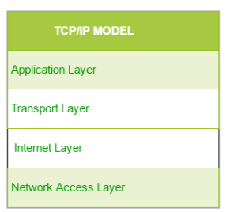

**Network Layer**

* This layer corresponds to the combination of Data Link Layer and Physical Layer of the OSI model.
* It looks out for hardware addressing and the protocols present in this layer allows for the physical transmission of data. We just talked about ARP being a protocol of Internet layer, but there is a conflict about declaring it as a protocol of Internet Layer or Network access layer.
* It is described as residing in layer 3, being encapsulated by layer 2 protocols.

**Internet Layer**

* This layer parallels the functions of OSI’s Network layer. It defines the protocols which are responsible for logical transmission of data over the entire network.

The main protocols residing at this layer are :

* **IP –** stands for Internet Protocol and it is responsible for delivering packets from the source host to the destination host by looking at the IP addresses in the packet headers.
* **ICMP –** stands for Internet Control Message Protocol. It is encapsulated within IP datagrams and is responsible for providing hosts with information about network problems.
* **ARP –** stands for Address Resolution Protocol. Its job is to find the hardware address of a host from a known IP address. ARP has several types: Reverse ARP, Proxy ARP, Gratuitous ARP and Inverse ARP.

**Transport Layer**

* This layer is analogous to the transport layer of the OSI model. It is responsible for end-to-end communication and error-free delivery of data. It shields the upper-layer applications from the complexities of data. The two main protocols present in this layer are :
* **Transmission Control Protocol (TCP) –** It is known to provide reliable and error-free communication between end systems. It performs sequencing and segmentation of data. It also has acknowledgment feature and controls the flow of the data through flow control mechanism. It is a very effective protocol but has a lot of overhead due to such features. Increased overhead leads to increased cost.
* **User Datagram Protocol (UDP) –** On the other hand does not provide any such features. It is the go-to protocol if your application does not require reliable transport as it is very cost-effective. Unlike TCP, which is connection-oriented protocol, UDP is connectionless.

**Application Layer**

* This layer performs the functions of top three layers of the OSI model: Application, Presentation and Session Layer. It is responsible for node-to-node communication and controls user-interface specifications. Protocols other than those present in the linked article are :
  + **HTTP and HTTPS –** HTTP stands for Hypertext transfer protocol. It is used by the World Wide Web to manage communications between web browsers and servers. HTTPS stands for HTTP-Secure. It is a combination of HTTP with SSL(Secure Socket Layer). It is efficient in cases where the browser need to fill out forms, sign in, authenticate and carry out bank transactions.
  + **SSH –** SSH stands for Secure Shell. It is a terminal emulations software similar to Telnet. The reason SSH is more preferred is because of its ability to maintain the encrypted connection. It sets up a secure session over a TCP/IP connection.